Lab - 0

Git, Git Bash & Preparing Lab Submission
1.Aim
To study the fundamentals of version control using Git, understand basic Git Bash commands, and learn the proper workflow for preparing and submitting lab assignments.

2. Theory
Git is a distributed version control system that allows developers to track changes, maintain history, and collaborate on projects efficiently. Unlike centralized systems, Git stores a complete history locally, making it fast and reliable.
Git Bash provides a Unix-like terminal interface on Windows, allowing users to execute Git commands easily.
Key Concepts:
- Repository (Repo): A folder where project files are stored and tracked
- Commit: A saved snapshot of changes
- Branch: A separate line of development
- Clone: Copying a repository from remote to local system
Workflow:
Working Directory → Staging Area → Local Repository → Remote Repository

3. Apparatus / Requirements
- Computer/Laptop
- Git
- Git Bash
- Internet connection

4. Block Diagram
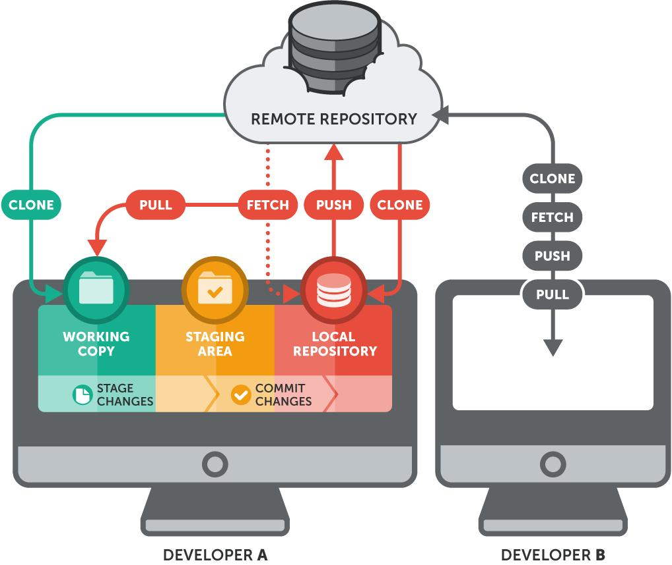
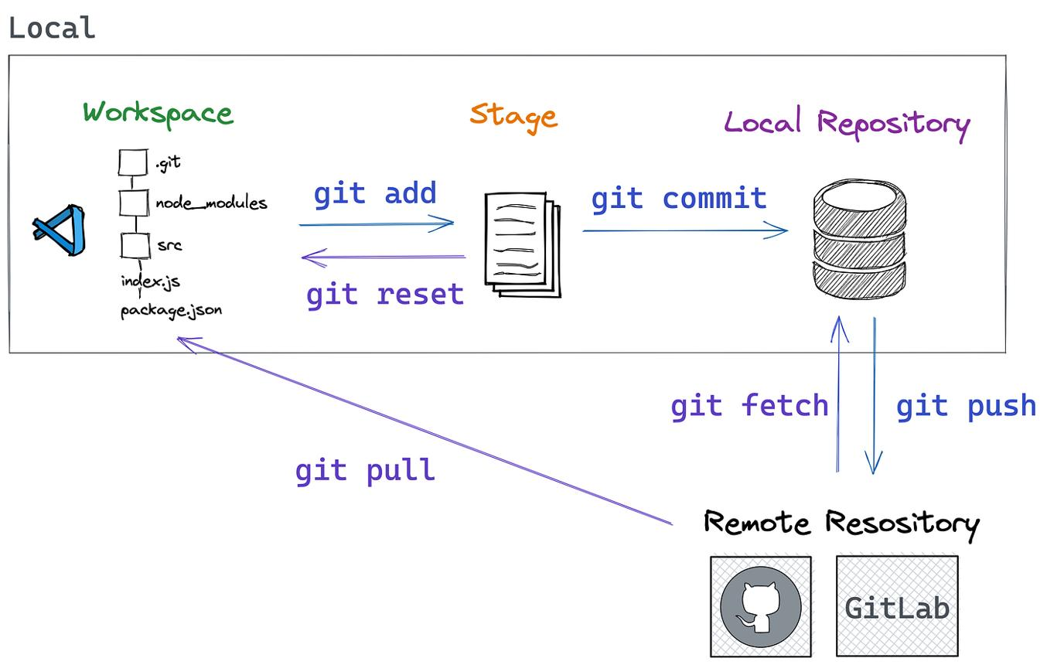

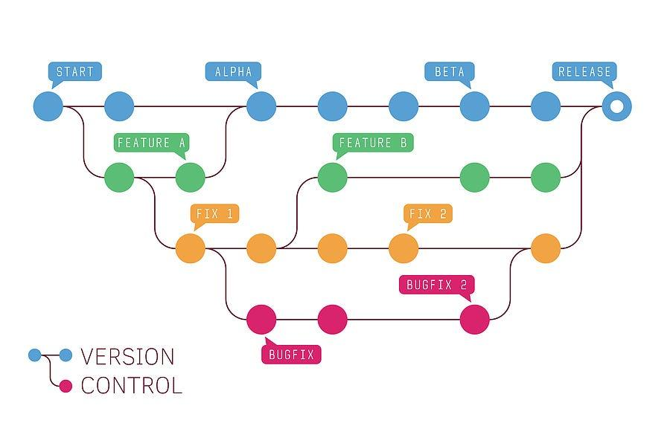

5. Procedure (Steps)
- Install Git software
- Open Git Bash terminal
- Configure user details:
  - git config --global user.name "Your Name"
  - git config --global user.email "email@example.com"
- Initialize repository using git init
- Create or copy files into the folder
- Add files using git add .
- Commit changes using git commit -m "message"
- Connect to remote repository
- Push files to GitHub

6. Program / Code
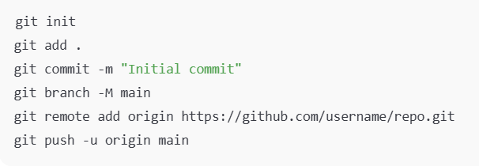

S7. Observations / Readings
- Git successfully initialized repository
- Files tracked and staged correctly
- Commit history created
- Files uploaded to remote repository

8. Result
The Git workflow was successfully implemented, and lab files were properly managed and submitted using Git Bash.

